A Project Report On
STOCKS MANAGEMENT



Under the Guidance of
Mr. Satpal Singh

Vanasthali Public School
A-461-462, Mayur Vihar Phase III, Delhi-110096

Contents

- Working Description
- Module Imported
- Coding
- Output
- Bibliography

Working Description
- To start the main program the User is asked about the Password which is the Password of SQL i.e. 123456(in this case)
- After this the program creates the database and the table for our program.
- Then the menu appears in which we can choose options for carrying out the mentioned operation.
- The User can view the products which are in the database(Supermarket) using the View Stocks Option(1).
- The user can also enter the information (Pno, PName, Brand, MRP, SellingP,Qty) of the product(Only If there is no entry with same Pno) in database using the Add product option(2).
- The user can also remove a record using Pno, PName or Brand of the product in database using the Remove product option(3).
- The user can also update the Pno, Name, Brand, Mrp, Sellingp, and Qty of the any record using the Update Products option(4).
- The user can also search records which are in the Database by Modes(Pno,PName,Brand,Qty).If multiple records found it will show multiple using the Search Record option(5).
- The user can also create billing for the sale using Generate Billing option(6).In this,first the user can see the stocks available and then later he needs to give the pno and amount of the product to be sold.(However the amount should be in the domain of the Qty of the stocks) and then a billing is generated and then user is asked whether he wants to update the Qty according the sold amount.
Module Imported

- mysql.connector
- To establish a connection between python(front end) and mysql(back end) and carry out the queries needed as per the program.
- datetime
- To capture system date and time and use it to display current date and time in the program.
- time
- To add some delay between parts of program

Coding
import mysql.connector as con
import datetime
import time

while True:
try:
pswd=input("Enter SQL Password:")
dbobj=con.connect(host="localhost",user="root",password=pswd,charset='utf8')
print("Connecting....")
time.sleep(2)
break
except :
print("***WRONG PASSWORD***")
crsr=dbobj.cursor()

def dbtable():
crsr.execute("create database if not exists supermarket")
crsr.execute("use supermarket")
crsr.execute("create table if not exists product(PNO int,PNAME char(20),BRAND char(20),MRP int,SELLINGP int,QTY int,primary key(PNO))")
def intro():
now = datetime.datetime.now()
print()
print("_"*85)
print("""
STOCK MANAGEMENT {}

0)EXIT
1)VIEW STOCKS
2)ADD PRODUCT
3)REMOVE PRODUCT
4)UPDATE PRODUCTS
5)SEARCH RECORD
6)GENERATE BILLING
""".format(now.strftime('%d-%m-%Y %H:%M')))

def intinp(stmnt):
y=0
while y==0:
try:
x=input(stmnt)
if bool(int(x))==True:
y=1
return int(x)
if x=="0":
y=1
return int(x)
except:
print("****Integer Value Required****")

def viewproduct():
print()
print("-"*105)
crsr.execute("desc product;")
recs=crsr.fetchall()
print(recs[0][0].ljust(7),recs[1][0].ljust(25),recs[2][0].ljust(25),recs[3][0].ljust(10),recs[4][0].ljust(10),recs[5][0].ljust(15),sep="")
crsr.execute("select * from product;")
recs=crsr.fetchall()
for rec in recs:
print(str(rec[0]).ljust(7),rec[1].ljust(25),rec[2].ljust(25),str(rec[3]).ljust(10),str(rec[4]).ljust(10),str(rec[5]).ljust(15),sep="")

def addproduct():
print("ADD PRODUCT".center(85,'='))
try:
n=intinp("Enter no. of records to be added:")
for w in range (n):
try:
pno=intinp("Enter PNO:")
pname=input("Enter PNAME:")
brand=input("Enter BRAND:")
mrp=intinp("Enter MRP:")
sellingp=intinp("Enter SELLINGP:")
stock=intinp("Enter STOCK:")
record=(str(pno),pname,brand,str(mrp),str(sellingp),str(stock))
print(record)
print()
confirm=input("Confirm(y/n):")
print()
try:
if confirm=="y" or confirm=="Y":
crsr.execute("insert into product values {}".format(record))
crsr.execute("commit")
print()
except con.errors.IntegrityError:
print("****DUPLICATE KEY NOT ALLOWED****")
except con.errors.DataError:
print("DATA TOO LONG")
except ValueError:
print("_____Wrong values_____")
except ValueError:
print("_____Wrong values_____")

def remove(by,val):
try:
crsr.execute("select * from product where {}='{}'".format(by,val))
rec=crsr.fetchone()
if rec==None:
print("EMPTY RECORD")
else:
crsr.execute("desc product;")
recs=crsr.fetchall()
print(recs[0][0].ljust(7),recs[1][0].ljust(25),recs[2][0].ljust(25),recs[3][0].ljust(10),recs[4][0].ljust(10),recs[5][0].ljust(15),sep="")
print(str(rec[0]).ljust(7),rec[1].ljust(25),rec[2].ljust(25),str(rec[3]).ljust(10),str(rec[4]).ljust(10),str(rec[5]).ljust(15),sep="")
confirm=input("Confirm(y/n):")
if confirm=="y" or confirm=="Y":
if by=="pno":
crsr.execute("delete from product where pno ={}".format(val))
elif by=="pname":
crsr.execute("delete from product where pname = '{}'".format(val))
elif by=="brand":
crsr.execute("delete from product where brand ='{}'".format(val))
crsr.execute("commit")
print("RECORD DELETED")
return
else:
pass
except:
print("_____Wrong values_____")

def removeproduct():
print("REMOVE PRODUCT".center(85,'='))
print("""
MODES:
0)EXIT
1)PNO
2)PNAME
3)BRAND""")
print("_"*85)
y=0
data=""
while y==0:
try:
print()
mod=input("Enter Mode:")
if mod=="0":
y=1
break
elif mod=="1" or mod=="pno" or mod=="PNO":
z=1
while z==1:
try:
val=intinp("Enter PNO")
if val==0:
z=0
else:
remove("pno",val)
z=0
except:
print("_____Wrong values_____")
elif mod=="2" or mod=="PNAME" or mod=="pname":
z=1
while z==1:
try:
data=input("Enter PNAME:")
if data=="0":
z=1
else:
z=0
remove("pname",data)
except:
print("_____Wrong values_____")
elif mod=="3" or mod=="BRAND" or mod=="brand":
z=1
while z==1:
try:
data=input("Enter BRAND:")
if data=="0":
z=1
else:
z=0
remove("brand",data)
except:
print("_____Wrong values_____")
else:
print("WRONG MODE SELECTED...")
except ValueError:
print("_____Wrong values_____")

def update(mod,pn):
try:
crsr.execute("select * from product where pno={}".format(pn))
rec=crsr.fetchone()
if rec==None:
print("EMPTY RECORD")
else:
crsr.execute("desc product;")
recs=crsr.fetchall()
print(recs[0][0].ljust(7),recs[1][0].ljust(25),recs[2][0].ljust(25),recs[3][0].ljust(10),recs[4][0].ljust(10),recs[5][0].ljust(15),sep="")
print(str(rec[0]).ljust(7),rec[1].ljust(25),rec[2].ljust(25),str(rec[3]).ljust(10),str(rec[4]).ljust(10),str(rec[5]).ljust(15),sep="")
confirm=input("Confirm(y/n):")
if confirm=="y" or confirm=="Y":
if mod=="pno":
newrec=intinp("Enter NEW PNO:")
crsr.execute("update product set pno={} where pno={}".format(newrec,pn))
elif mod=="pname":
newrec=input("Enter NEW PNAME:")
crsr.execute("update product set pname='{}' where pno={}".format(newrec,pn))
elif mod=="brand":
newrec=input("Enter NEW BRAND:")
crsr.execute("update product set brand='{}' where pno={}".format(newrec,pn))
elif mod=="mrp":
newrec=intinp("Enter NEW MRP:")
crsr.execute("update product set mrp={} where pno={}".format(newrec,pn))
elif mod=="sellingp":
newrec=intinp("Enter NEW SELLINGP:")
crsr.execute("update product set sellingp={} where pno={}".format(newrec,pn))
elif mod=="qty":
newrec=intinp("Enter NEW QTY:")
crsr.execute("update product set qty={} where pno={}".format(newrec,pn))
crsr.execute("commit")
print("RECORD UPDATED")
return
else:
pass
except:
print("_____Wrong values_____")

def updateproduct():
print("UPDATE PRODUCT".center(85,'='))
print("""
0)EXIT
1)PNO
2)PNAME
3)BRAND
4)MRP
5)SELLINGP
6)QTY
""")
y=0
data=""
while y==0:
try:
print()
mod=input("Enter Mode:")
if mod=="0":
y=1
break
elif mod=="1" or mod=="pno" or mod=="PNO":
z=1
while z==1:
try:
no=intinp("Enter CURRENT PNO: ")
if no==0:
z=0
else:
update("pno",no)
z=0
except:
print("_____Wrong values_____")
elif mod=="2" or mod=="PNAME" or mod=="pname":
z=1
while z==1:
try:
no=intinp("Enter CURRENT PNO: ")
if no==0:
z=1
else:
z=0
update("pname",no)
except:
print("_____Wrong values_____")
elif mod=="3" or mod=="BRAND" or mod=="brand":
z=1
while z==1:
try:
no=intinp("Enter CURRENT PNO: ")
if no==0:
z=1
else:
z=0
update("brand",no)
except:
print("_____Wrong values_____")
elif mod=="4" or mod=="MRP" or mod=="mrp":
z=1
while z==1:
try:
no=intinp("Enter CURRENT PNO: ")
if no==0:
z=1
else:
z=0
update("mrp",no)
except:
print("_____Wrong values_____")
elif mod=="5" or mod=="SELLINGP" or mod=="sellingp":
z=1
while z==1:
try:
no=intinp("Enter CURRENT PNO: ")
if no==0:
z=1
else:
z=0
update("sellingp",no)
except:
print("_____Wrong values_____")
elif mod=="6" or mod=="qty" or mod=="QTY":
z=1
while z==1:
try:
no=intinp("Enter CURRENT PNO: ")
if no==0:
z=1
else:
z=0
update("qty",no)
except:
print("_____Wrong values_____")
else:
print("WRONG MODE SELECTED...")
except ValueError:
print("_____Wrong values_____")

def searchby():
print("SEARCH PRODUCT".center(85,'='))
print("""
MODES:
0)EXIT
1)PNO
2)PNAME
3)BRAND
4)QTY""")
print("_"*85)
y=0
data=""
while y==0:
try:
print()
mod=input("Enter Mode:")
if mod=="0":
y=1
break
elif mod=="1" or mod=="pno" or mod=="PNO":
z=1
while z==1:
try:
val=intinp("Enter PNO:")
if val==0:
z=0
else:
searchrecord("pno",val,"int")
z=0
except Exception as e:
print("_____Wrong values____",e)
elif mod=="2" or mod=="PNAME" or mod=="pname":
z=1
while z==1:
try:
data=input("Enter PNAME:")
if data=="0":
z=1
else:
z=0
searchrecord("pname",data,"chr")
except:
print("_____Wrong values_____")
elif mod=="3" or mod=="BRAND" or mod=="brand":
z=1
while z==1:
try:
data=input("Enter BRAND:")
if data=="0":
z=1
else:
z=0
searchrecord("brand",data,"chr")
except:
print("_____Wrong values_____")
elif mod=="4" or mod=="qty" or mod=="QTY":
z=1
while z==1:
try:
val=intinp("Enter QTY:")
if val==0:
z=0
else:
searchrecord("qty",val,"int")
z=0
except:
print("_____Wrong values_____")
else:
print("WRONG MODE SELECTED...")
except ValueError:
print("_____Wrong values_____")

def instock(pno,demand):
z=1
while z==1:
try:
crsr.execute("select * from product where pno={}".format(str(pno)))
data=crsr.fetchone()
cqty=data[5]
if cqty==0:
print(data[1]," IS OUT OF STOCK")
return 0
elif demand>cqty:
print("Sorry,we only have",cqty)
ch=intinp("Want to buy all?(0/1)")
if ch==1:
return cqty
else:
return 0
else:
return demand
except Exception as err:
print("_____Wrong values_____",err)

def searchrecord(by,val,typ):
try:
if typ=="int":
crsr.execute("select * from product where {}={}".format(by,str(val)))
data=crsr.fetchall()
if data==[]:
print("EMPTY RECORD")
else:
crsr.execute("desc product;")
recs=crsr.fetchall()
print(recs[0][0].ljust(7),recs[1][0].ljust(25),recs[2][0].ljust(25),recs[3][0].ljust(10),recs[4][0].ljust(10),recs[5][0].ljust(10),sep="")
for rec in data:
print(str(rec[0]).ljust(7),rec[1].ljust(25),rec[2].ljust(25),str(rec[3]).ljust(10),str(rec[4]).ljust(10),str(rec[5]).ljust(10),sep="")
elif typ=="chr":
crsr.execute("select * from product where {}='{}'".format(by,val))
data=crsr.fetchall()
if data==[]:
print("EMPTY RECORD")
else:
crsr.execute("desc product;")
recs=crsr.fetchall()
print(recs[0][0].ljust(7),recs[1][0].ljust(25),recs[2][0].ljust(25),recs[3][0].ljust(10),recs[4][0].ljust(10),recs[5][0].ljust(10),sep="")
for rec in data:
print(str(rec[0]).ljust(7),rec[1].ljust(25),rec[2].ljust(25),str(rec[3]).ljust(10),str(rec[4]).ljust(10),str(rec[5]).ljust(10),sep="")

except:
print("_____Wrong values_____")

def billing():
print("BILLING".center(90,'='))
viewproduct()
pnolist=[]
qtylist=[]
y=0
sm=0
print("ENTER PNO AS 0 TO EXIT")
print()
while y==0:
try:
no=intinp("Enter PNO:")
if no==0:
sm=0
disc=0
tdisc=0
smprice=0
print("-"*85)
crsr.execute("desc product;")
recs=crsr.fetchall()
print(recs[0][0].ljust(3),recs[1][0].ljust(20),recs[2][0].ljust(20),recs[3][0].ljust(7),recs[4][0].ljust(8),"AMOUNT".ljust(7),"PRICE".ljust(7),"DISC".ljust(4),"COST".ljust(7))
for i in range(len(pnolist)):
crsr.execute("select * from product where pno={}".format(pnolist[i]))
rec=crsr.fetchone()
cost=int(rec[4])*qtylist[i]
mrp=int(rec[3])
tmrp=mrp*qtylist[i]
sm=sm+cost
disc=tmrp-cost
tdisc=tdisc+disc
smprice=smprice+tmrp
print(str(rec[0]).ljust(3),rec[1].ljust(20),rec[2].ljust(20),str(rec[3]).ljust(7),str(rec[4]).ljust(8),str(qtylist[i]).ljust(7),str(rec[3]*qtylist[i]).ljust(7),str(disc).ljust(4),str(cost).ljust(7))
print("%58s %6s"%("TOTAL PRICE:",smprice))
print("%58s %6s"%("TOTAL DISCOUNT:",tdisc))
print("%58s %6s"%("AMOUNT TO BE PAID:",sm))
print('''
0) No
1) Yes''')
ch=intinp("Want To Update QTY?(0/1):")
if ch==1:
for i in range(len(pnolist)):
crsr.execute("update product set qty=qty-{} where pno={}".format(qtylist[i],pnolist[i]))
print("QTY UPDATED")
crsr.execute("commit")
else:
print("QTY NOT UPDATED")
break
y=1
else:
z=0
while z==0:
amt=intinp("Enter amount:")
amount=instock(no,amt)
if amount!=0:
crsr.execute("select * from product where pno={}".format(no))
rec=crsr.fetchone()
if rec==None:
print("_____Wrong values_____")
z=1
else:
cost=int(rec[4])*amount
sm=sm+cost
crsr.execute("desc product;")
recs=crsr.fetchall()
print(recs[0][0].ljust(3),recs[1][0].ljust(20),recs[2][0].ljust(20),recs[3][0].ljust(7),recs[4][0].ljust(8),"AMOUNT".ljust(7),"COST".ljust(7))
print(str(rec[0]).ljust(3),rec[1].ljust(20),rec[2].ljust(20),str(rec[3]).ljust(7),str(rec[4]).ljust(8),str(amount).ljust(7),str(cost).ljust(7))
print()
pnolist.append(no)
qtylist.append(amount)
z=1
break
except ValueError:
print("_____Wrong values_____")

def main():
dbtable()
while True:
time.sleep(1)
intro()
option=input("Enter Option:")
if option=="1":
viewproduct()
elif option=="2":
addproduct()
elif option=="3":
removeproduct()
elif option=="4":
updateproduct()
elif option=="5":
searchby()
elif option=="6":
billing()
elif option=="0":
print("Thanks for using...")
break
else:
print("Try Again")
main()

Output
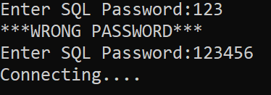
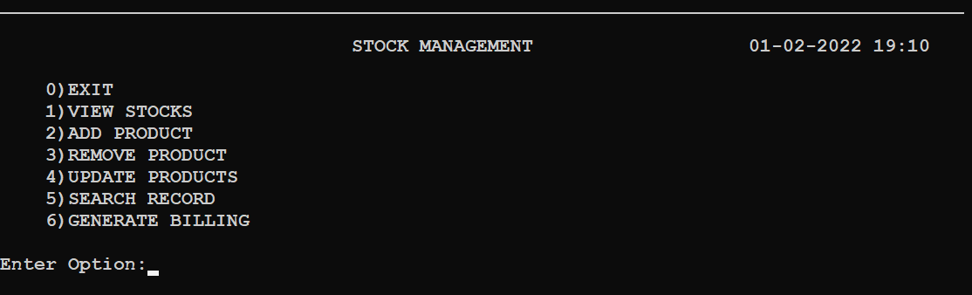

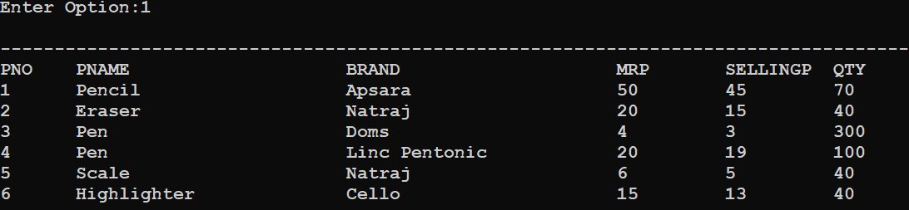

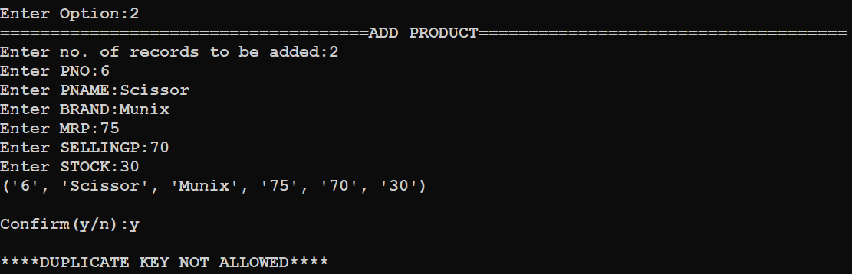
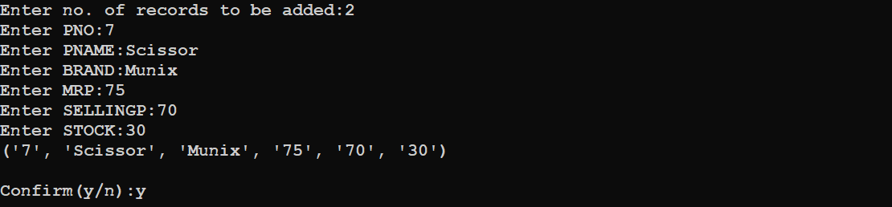

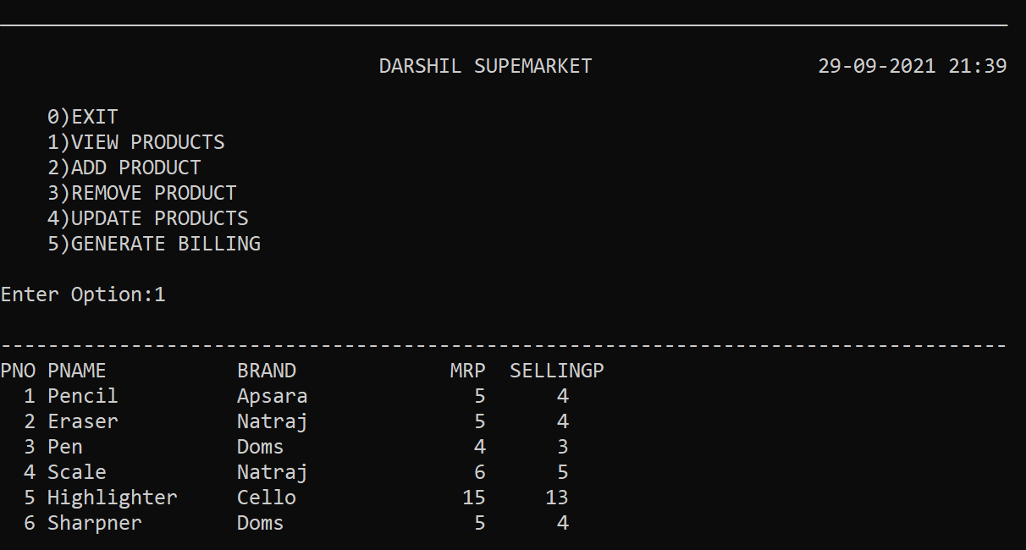

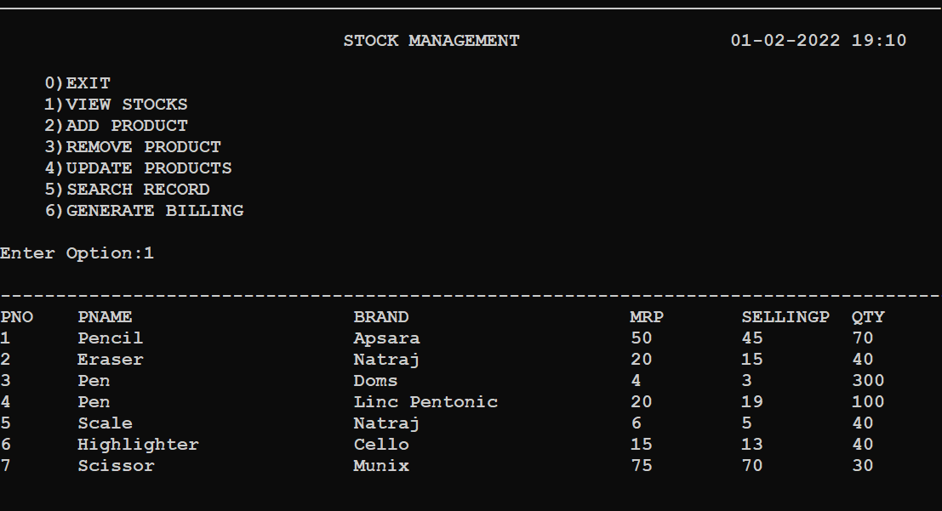

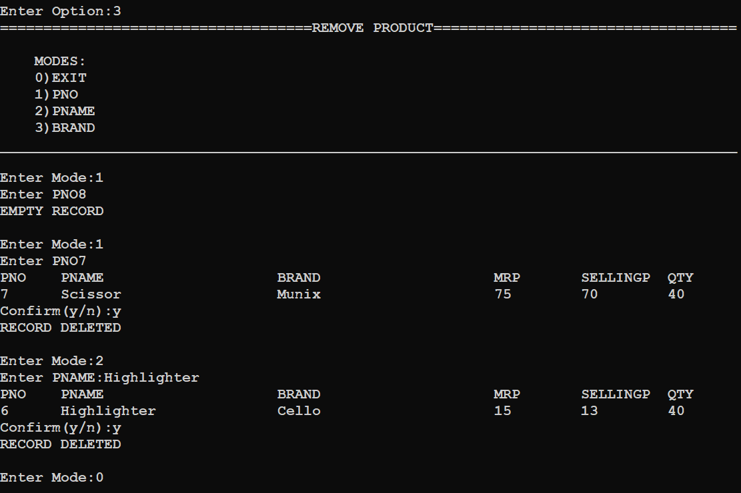

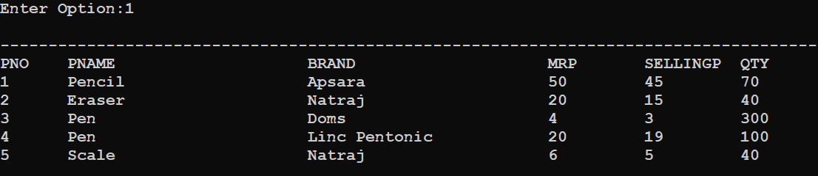

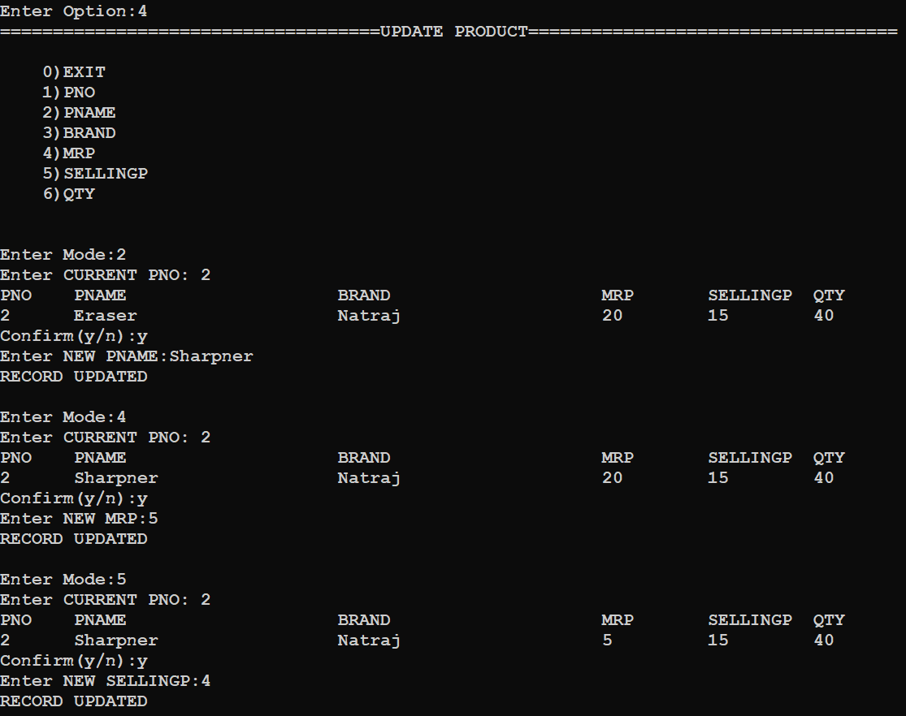

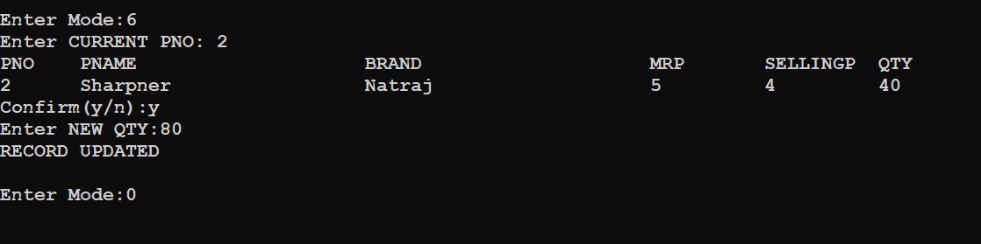

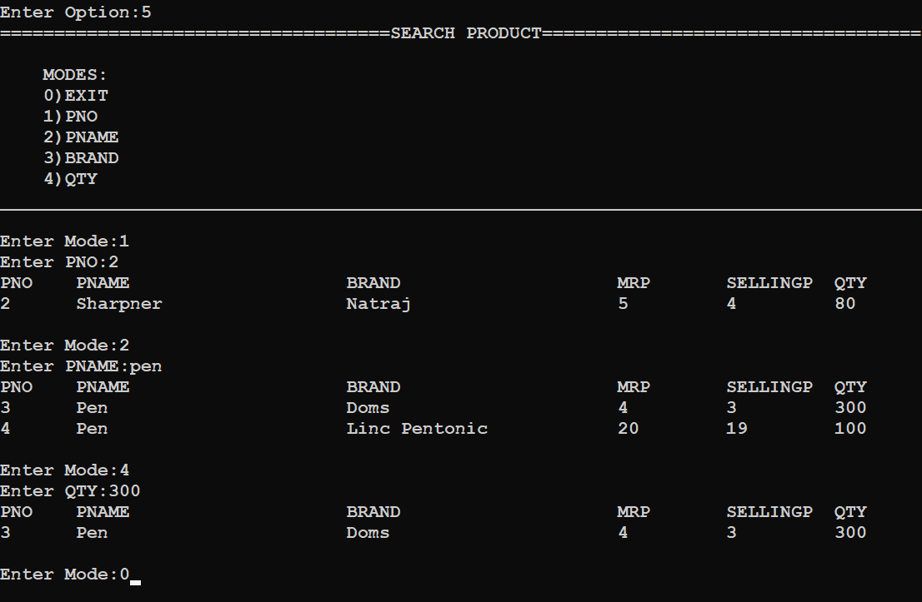

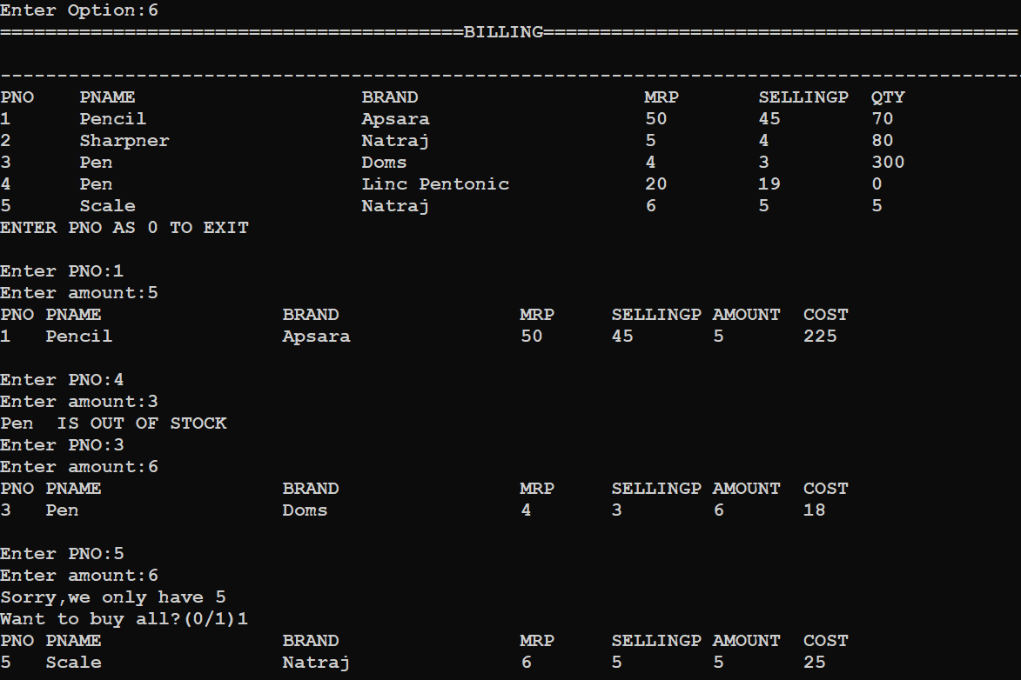

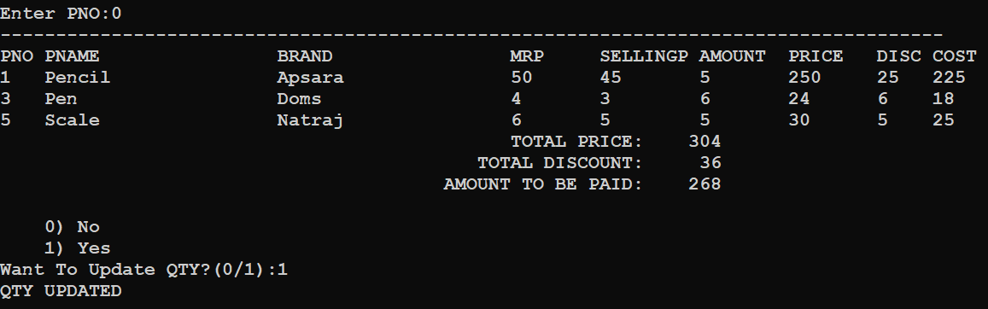

Bibliography
http://www.google.com/
https://www.w3schools.com/
https://www.geeksforgeeks.org/
Computer Science with Python by Sumita Arora

